# Task 6: Sales Trend Analysis using Aggregations:

First 10 rows:

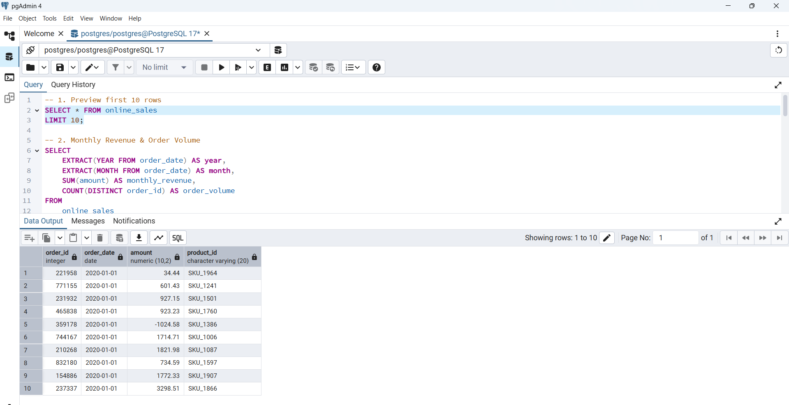

2. Monthly Revenue & Order Volume

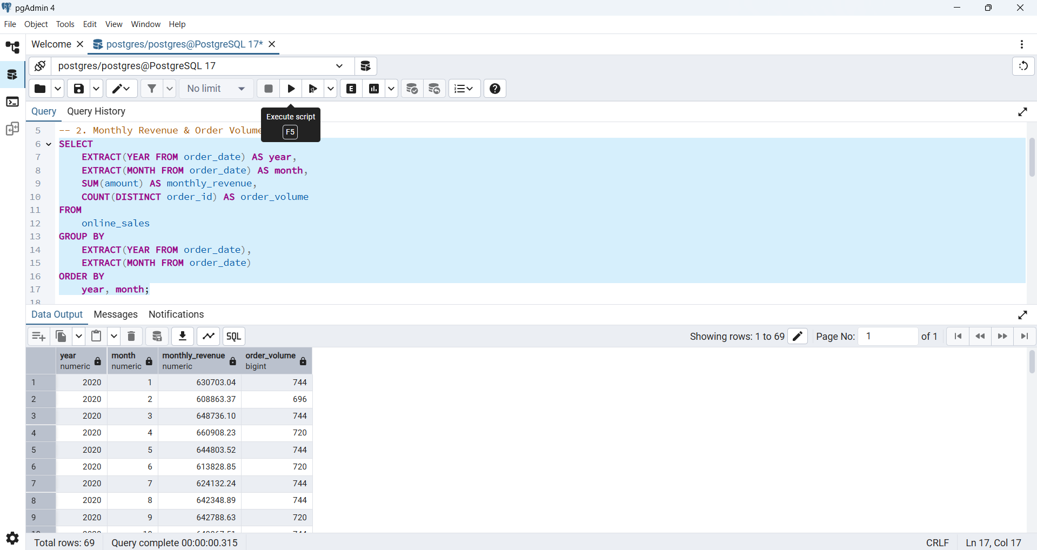

3. Top 3 Months by Revenue

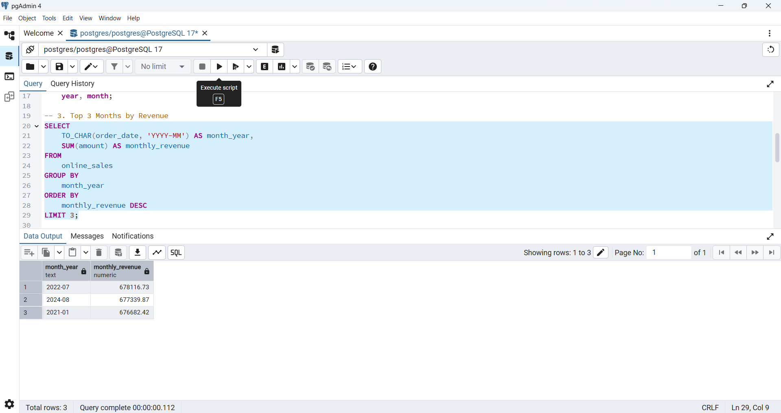

4. Total Revenue Overall

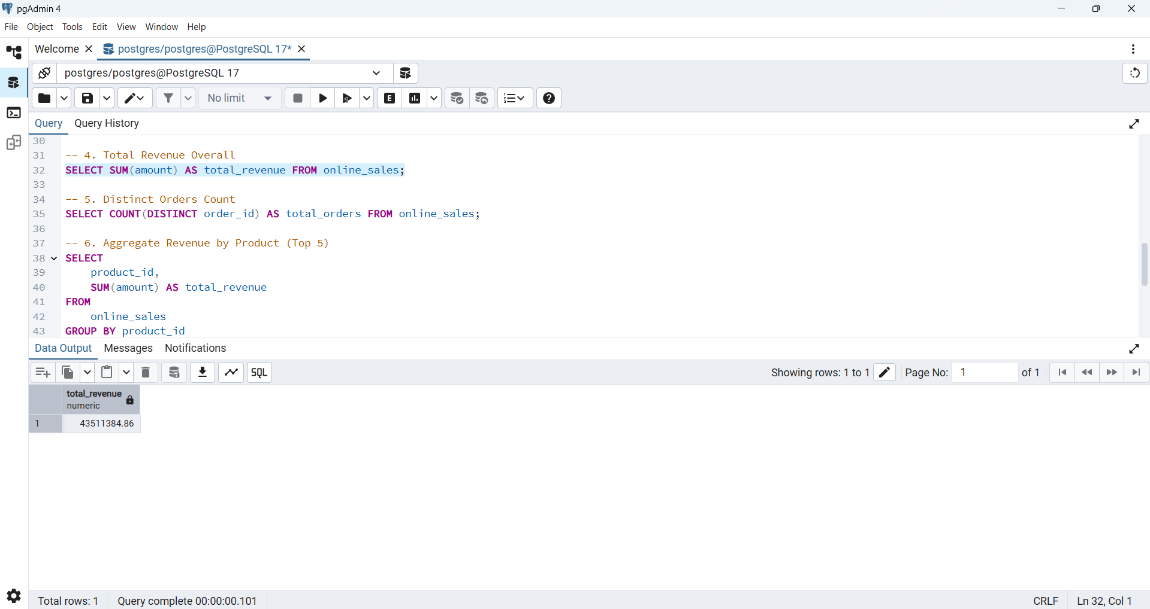

5. Distinct Orders Count

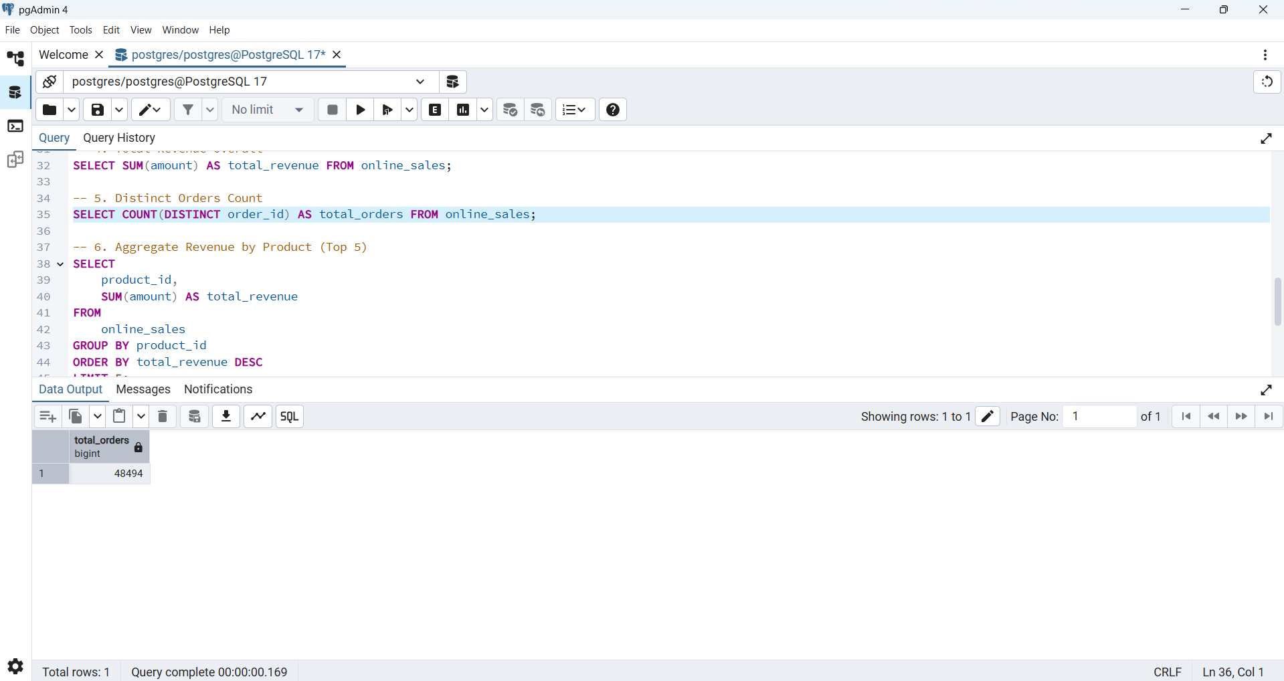

6.Aggregate Revenue by Product (Top 5)

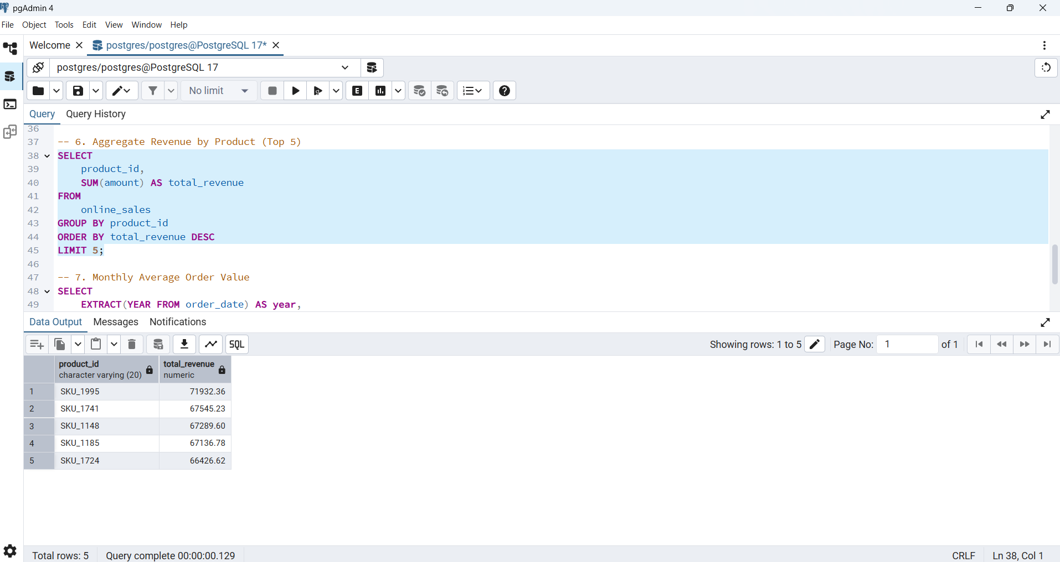

7. Monthly Average Order Value

